Revolution in mental health management
& self-prescription

John M. Slater
January 2026

“Everyone you meet is fighting a battle you know nothing about. Be kind. Always,” attributed to Robin Williams
Robin Williams is one of those people who quietly made a difference to so many lives, through humour, honesty, and his unannounced and unpublicised acts of kindness. He took his own life after many years struggling with depression leaving the world a sadder place.
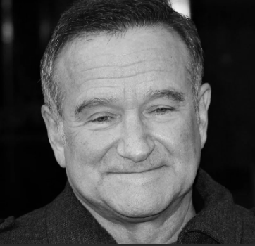
My depression is not being treated
- I have medication
- I went to a mental health specialist
- It is being dealt with as a singular word, condition that fits a list of words in an approved book.
- No, my depression is not being treated
I am not a mental health qualified person, but am now better read, than before and have many years of experience personally, in my family and talking to colleagues and friends and I have a view. There is a focus on UK in this article, as my knowledge of international mental care services is limited, however the suggestions are just as applicable globally.
This article is NOT a one-sided negative view of the mental health profession, indeed, I have been fortunate enough, as has my mother and daughter, to deal with people who took their calling and are excellent in their role. It does however look at some areas where improvements might be considered, and looks at mental health from a personal point of view, my view, after more than a year of self-reflection and reading.
I will not talk about mental health help lines in this article, however want to acknowledge the valuable and challenging work they do for so many mostly staffed by volunteers.
The article explores the relationship between the parties in the previous diagram, with a focus on the services and companies being enablers for the individuals, which in many circumstances they are today, however as the article will cover we need a revolutionary shift to prevention and healing the cause.
A moment in time
There is the moment in time diagnosis, which again I understand. Even an amazingly good mental health professional can only go on what you tell them on a day. It is a rubbish day, maybe I will get 300mg dose, it is a good day, maybe 100mg, or maybe a different medical view point and no medication. Then there is the wait. The NHS Constitution advises that treatment for depression should be started within eighteen weeks [of diagnosis]. My experience in Scotland and England was that treatment was started early based on an assessment of a GP using the NHS guidelines, however the wait to see a psychiatrist was about eight months, and long time for a clinical diagnosis, that occurs in an hour session, when our mental health can vary greatly in this time and during appointments.
When I crashed out of society in 2019, I was in a very bad way and coping through alcohol, a form of self-harm. I was prescribed high doses of antidepressants and more which I had a need for, in the absence of connection, walks, the sea, countryside, a dog and more. “Rest and take the medications” with a diagnosis of acute depression was the advice, and because I had insurance and was abroad, I was seen regularly. From that moment forward, I have been in that box.
I understand that any sphere of science, culture and more require a system that classifies what is found, here referred to as “box.” This is needed to order learning and advancement. However, systems are made by humans for humans, and will always be flawed. The question is to what extent are they flawed.
The classification of mental illness is needed, I support this, however as it is a subjective diagnosis I do not support the one time and forward diagnosis, without consideration. I was treated for the complex condition (are not all complicated) of “depression.” Depression is an outcome and treating an outcome is not dealing with the cause. We have learned this the hard way in industry. The cause will never be found in a few 1-hour sessions. Indeed, the exact form of depression I exhibited is “High Functioning Depression” ^{[3]} where I could work, engage, take decisions, strategize, all the time with nobody seeing the outside work me, which was a desperate, sad, and spinning downwards human being. This form is still not formally recognised, but exhibited by too many people I know.
The USA primary reference (DSM-5-TR 2013) has long been debated as being created by a committee too close to the pharmaceutical industry ^{[5]}, a criticism that if correct would cause broader categorisation and more dependence of drugs for treatment of mental disorders to be preferred by a trusted body of professionals against a focus on healing and cure. Indeed 69% ^{[5]} of the taskforce who developed the classification system reported having financial ties to the pharmaceutical industry.
The widely used IDC (ICD-11) system of classification developed by the WHO appears to be less prone to industry interference, although lobbying for new codes is possible. The ICD also encourages more than one diagnosis if required, which does give some flexibility within the small number of codes used for depression, as an example. In the UK the ICD appears to be the primary reference for NHS Standards, although interestingly, the National Institute for Health and Care Excellence (NICE) refers to DSM-5 for classification of depression, meaning that the US system influence stretches to the UK.
I am NOT knocking the pharmaceutical industry as they are companies making money for shareholders, and without the billions they spend on R&D the world would be a worse off place with much worse mortality rates and human suffering.
I do see a need for flexible thinking, changing diagnosis and more complex thinking on how to allow people to cope, whilst healing and discovering through assisted or solo efforts. Therapy can be a long wait unless you have access to private care or have enough money. Through therapy, GP’s, and psychiatrists at no time was it suggested I read up on my condition, nor were available references given to me, as if I am a child incapable of assimilating and working with such information. I was curious but only in 2024 and 2025 became curious enough.
Only in my lows
I have mostly been seen by professionals when I was in a bad way, and at times in the past seriously planning to take my own life (suicide), so the dosage went up mostly, but occasionally down, and the medication changed over time. Well-meaning, highly trained and competent people with an hour to take a massive decision on my near term and midterm future with little context around my life in a depressive state was not enough, but all they were able to give me, and I was grateful. I was lucky for a year I had a well-trained therapist. We talked about coping and the recent past as well as the childhood past but somehow failed to work deep enough to look at the causes of my long-term depression, and maybe why it was high performing depression and not low performing or other forms of depression.

On a spectrum
“Please don’t worry about me. I’m doing fine. I’m just going through a little bit of a rough patch.” Robin Williams in one of his final interviews
We are all on a spectrum of mental health all the time. From maybe ten as very good, content, happy and motivated, to one being suicidal, hopeless with nowhere and no one to turn to. When you get to one or two on the spectrum you can stay there consistently for many days, months or even years, with devastating physical as well as mental health impacts. If you are fortunate enough to find ten, it’s not every day. Each day in our lives can bring different experiences that we process and deal with in different ways, hence we are all on a spectrum all the time. Most will see large swings maybe brought about by current events in life, or maybe by past events, and the ideal is that we return to an above average undulating state. I have used the “1 in 4” quotes of people in society suffering from mental illness at any time, and there are definitions of when low mood is classified or coded/treated as mental illness in the references given earlier. But we can swing wildly and maybe fall over the brink into a diagnosis of mental illness. Maybe we should talk about “4 in 4” having mental health ^{[10]} swings. I have supported the term “illness” but am starting to move towards the term “state” or “current condition.” In my case in 2025 I am in such a different place from 2019 and 2021 and indeed 2024 that I struggle to call myself “ill”. I am still on medication but am questioning is it depression driving symptoms if I have no medication or withdrawal from the medication itself as was the case in hospital recently. More on this later, as I do not support stopping medication without talking to doctors or suitably qualified and competent persons, however antidepressants are not cures, they are coping aids.
Over the last few years there have been times when I could say (using illness terms) am cured, in remission or even ill. There are separated times when I fitted into all categories, but I have embraced this over time and accept good and bad days just as everybody else in society, albeit bad days were difficult when at work.
Coping and escaping
“You treat a disease, you win, you lose. You treat a person, I guarantee you, you'll win, no matter what the outcome” Robin Williams.
There is escaping, coping, and treating. Coping is how to make the best without delving into to the deeper experiences. Coping is important to allow time to heal through understanding the core cause of the “voice” that drives your life. There are healthy and less healthy coping mechanisms, there are escape mechanisms and coping mechanisms. Escape maybe alcohol, self-harm, drugs and whereas I am not condoning these escape mechanisms they must not be demonised by “specialists” and professionals, which has been my experience when going too heavy on alcohol in bad times. “Come back when you can control your drinking and we’ll talk about your dosage” was as good as saying you are a dumb ass and have no hope. He was wrong and I am proving it without his demonising hard stare. I could give this person the benefit of the doubt, he was overloaded, but no, no listening and lectures on the life shortening impacts of alcohol on that day just left me frustrated at the care that others would receive from this inept person who may well have chosen the wrong profession.
In this matter, I ask a question. Just as in all spheres of study, as they proliferate, there is a tendency to fill all positions as quickly as possible with available people with the minimum qualification. I have seen this in industry for safety and other specialist positions. As the profession matures, so does the quality of those in the profession in many cases. Has the mental health profession, in a well-meaning effort to provide services, hired and developed too many unsuitable for this most human of human services, and are there the feedback loops that would weed such people out over time. Those doing as below should be some of the first to go. Is Principle number four of the NHS (England) Constitution truly lived by all mental health professionals “The patient will be at the heart of everything the NHS does.”
Demonising does zero good, but may make the professionals feel they are doing their job, and allows a tick in the box, and yes, I have seen senior mental health professionals attend a relative in their most desperate of times with depression with a form and ticks boxes slowly getting crossed off with little listening, who was politely asked to leave the house.
Coping notes
Coping can take so many forms. They must be enjoyable and/or peaceful, such that you want to return to them. For me it is walking in nature or just observing nature in the city, music and when I can, being near the sea.
Can a doctor prescribe three walks a week, one day by the sea, one night with friends at the pub? Rather than a sick note why not a “coping note.” I am convinced in many, but not all cases, these notes would work better and allow people to process fragmented experiences of past experiences better, if given the tools and the environment to do it in. Or as a company in Sweden, that was recently reported on in the BBC does, can companies step in, and in this case give employees time off to meet friends. One thing is certain, more mental health professionals is only a part of the answer, and a dramatic company and society driven shift towards prevention and healing through providing coping and healing opportunities is required. We need revolution not evolution, from every corner of society and companies themselves need to step up and cease relying on health services, seeing the mental health of the workforce as a core element of productivity. What gets measured gets done, and behaviour changing goals need to be put in place at the very top of the company as part of the reward structure if they are to be effective.
I am also real, have worked in and understand countries where employment laws are weak, where employers could use such Coping Notes to remove people or at least discriminate. Such is the world we still live in with the short-sighted nature and bias of many societies and companies.
Going deeper
Acute or chronic depression and many other mental illnesses (but not all) are a symptom of something or things/events in life. It is even suggested in the book by Judith Joseph that trauma in one generation can affect following generations through switching on distinct genes that are carried forward.
In our lives poor mental states may be activated by current events but is based deeper and is a multifaceted condition, where understanding the base event(s) and finding a safe world with the clear memory of the emotions that were experienced is where we need to go. But that takes time, and a good therapist that takes time and access means money or long waits. There have been a proliferation of online therapists over time and I am sure many are excellent, however if a person is not flush with money and you want more sessions from them, telling them words or narratives they do not feel comfortable with could drive them away. There is the sceptic in me.
This brings me to the sceptic mentality. Alongside curious, I am sceptical and questioning, often asking the question “why?” when told I should do something. If there is no clear “why” there is no clear reason to follow. I have had mixed reactions to this question, notably short answers to fit the session into the slotted time allocated.
Recognising an overloaded and rigid system, full of many great people but also people who have lost or never had the capacity to listen. I have been on a journey of my own, since publishing two books back in 2019 and 2022, which were very much personal accounts and used many terms I had taken from the people I had been seen by up to that time.
A journey of self-learning
“You will have bad times, but they will always wake you up to the stuff you weren't paying attention to” Robin Williams
I have been reading as many reliable references, books and more, exploring subjects such as consciousness and delving into my own life experiences. The first book I read, which started my journey was the book by Norman Doidge M.D. - The Brain That Changes Itself. It is very much a book about the biology and anatomy of our brains and deals with our own capability to shape how our brains work, and hence shape our future. I came to the realisation that prior to this time I had read peer reviewed references and articles, however had been using confirmation bias, that is reading them to affirm my own preconceived and taught ideas, those I had been told by many professionals on my “illness,” the need for medication and on coping mechanisms. I had come to almost demonise myself as a failure despite accessing help, and had a dedicated focus on coping as opposed to healing. Once I started reading with an open mind (but still a little sceptical) open to new ideas and ways of thinking and a focus on preparing for healing, healing, and returning to a better version of the old me, I was gripped by new information and my creative mind started to join dots between many references and ideas.
I have moved back towards creativity in my life, a characteristic or capability that I believe is critical in healing, the ability to imagine and see yourself outside your current paradigm, your current way of living or existing. I sing, paint and video, but any form of creativity or unlearning is helpful in this effort. The next table is colour coded by key periods of brain development in our lives. My primary focus was zero to 9 years of age, being the period of greatest development of our brains.

Age | Description | Repetitive | Evokes emotion
0 | Hernia operation | No | No
3 | Asthma attack blue light ambulance to hospital | Yes | Good
3 - 7 | Asthma attacks to multiple hospitals, parents not allowed after visiting hours even if could not breathe well | Yes | No
6 | Minor operation | No | No
6 | My grandfather died, that I don’t recall much about | No | No
5 - 10 | Asthma kept me from doing PE and I had to sit with uniform outside changing room waiting for other children to finish | Yes | Strong emotion

Age | Description | Repetitive | Evokes emotion
10-12 | Fainted regularly from lack of oxygen to brain pushing myself too hard | Yes | Good
15 onwards | Would listen to my Gran tell harrowing and graphic stories from the second world war, which she needed to tell | Yes | No
18 | Close Aunt died, I had to tell my Gran at home | No | No
21 | Nan died, although we were unfortunately not close | No | No
25 | First encounter toxic boss, who eventually filed false safety incident report to get me suspended. Complained, won and rehired | No | No
32 | In traffic at red light when shoot out started between police and bank robbers, with stray rounds. | No | No

Age | Description | Repetitive | Evokes emotion
34 | Tailed by criminals for car or kidnap, shook them | 3 | No
38 | As ER on duty had to break news to parents their daughter had died in a road accident. Coordinated response for repatriation of body and family | No | Still strong
35 | Gran died, who I was very close to | No | Yes
37-50 | Fatality investigator on call and investigated multiple serious and fatal accidents | Yes | No
41 | As first responder attended a road accident as member of public of badly injured 18 years old until arrival of emergency services | No | No
41 | Daughter contracted meningitis aged 11 and was very close to death – survived after medical evacuation | No | Yes
45 | Second run in with toxic manager, causing me to leave company of 14 years, but with a settlement as the decision was arrived at through boss anger at me | No | No
I stop here as the depression was well and truly set in

My homework started with a trauma tree (or maybe a SNELE tree) shown above, a list by age of events and series of events that I may not see as traumatic or at least negatively impacting, but my younger brain found them so. I took this idea from the book High Functioning Depression by Judith Joseph. I recognise my trauma is not significant relative to other peoples’ dramatic traumas, however we must go back to the word trauma or use significant negative emotional life event(s) (SNELE) to be more inclusive. This exercise was liberating and I found an unexpected series of events as a child ill with asthma that triggered a deep emotion in me. I sobbed when I thought back to those times.
I realised that I could cope for years and go up and down in mood on the spectrum, but the only way to heal was to identify and almost relive SNELEs in a safe world to help whatever part of my brain and/or consciousness know that that was not my fault and it’s a time gone.
I was sat at school, maybe aged 6, 7,8, 9 or 10, I do not recall the exact times I had bad asthma and ended up in hospital often. Now maybe the SNELE of being on my own in a strange hospital outside visiting hours (when parents were told to leave) that were short, not able to breath well, would be impacting but I do not remember it that way, and thinking back brings few emotions forward.

I am at school; my class is doing physical education (PE). I am not, as my asthma is bad. I am in my uniform sitting outside the changing room with people passing me by. I am on a hard gym bench that I remember the touch and feeling of. I recall compassionate looks. In my head I am weaker than the children doing PE. People were kind but I was a regularly the “sick kid.” No control, inferior, different, embarrassed, and more.
I wrote a list of the emotions I must have had as an unsure youngster, as I cannot clearly recall them all like a video and I used a feelings wheel.
Telling myself I am not that person any more. I have gone past that time and lived a life, was therapeutic and a great help.
A constant voice
A book I am completing currently, looks at self-help, albeit in novel ways, that pushed me further on my road of delving hard and emotionally into my past as well as the idea of consciousness. It is by Rose Cartwright ^{[10]}, and where as I do not have an intention of going down the use of psychotic drugs to go deeper without a doctor’s advice, it raised many interesting questions I am keen to answer, as well as talking about the voice in our heads. I have tried hypnotherapy which did provide short lived benefits, but these faded as I lost the motivation to continue the long exercises.
There was the constant voice in my head stemming from those experiences or those and more:
You are not as good as them
You will not make it
You cannot resist that (alcohol)
You are not a great human specimen
Keep control of as much as you can in your life
You did not do that well
They did not look at me like I did well
I am sure they are talking about me
These voices have driven my child hood and adult behaviours.
- A workaholic to prove I am as good at school and work
- A control focus especially outside work
- You can be good on your own, and you must be
- An imposter on senior tables up to board level.
- Replaying interactions repeatedly with the worst conclusion
- Not listening to all the good advice, I was given in my earlier career and in life
This voice is an unhelpful defence, as is the depression. It is a deep routed defence to ensure I do not get into the same situation again. But it is a voice, or an alter ego that is us unhelpful and I have been telling it to go away a lot. I have used words like “dark” for my lows, but I have turned this around in my head. They were scary, suicidal times but I will not demonise the voice, just I would not demonise anybody in coping or escaping. It is not dark nor truly bad; it has been imprisoning you/me out of misguided love.
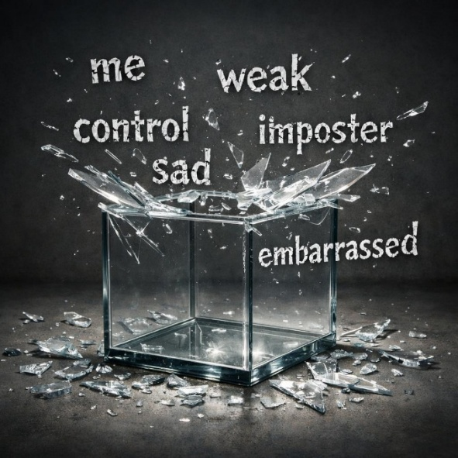
Understanding it is a defence that has tied me down, has helped me break away. I am not tied to the voice any more. I am silencing it.
I am and always was so much more.
Do not try to stop me
My coping mechanisms are still needed primarily because I enjoy them. Yes, a glass of red wine or two on an evening watching a good film or maybe in the pub with my brothers is enjoyable but the wine is not needed, it is enjoyed and left there.
Losing control
At work I was big on delegation and empowerment but admitted in some circumstances preferred control. May be that was why I was good at seeing pitfalls that were ahead at a strategic and operational level, planning and emergency management, as my brain worked in sequences, with contingencies springing from every side. The need to be able to exert control not just on today, but the future was strong, but needed to be silenced at times.
At home, as I wrote in first book Sing Through It, I was an angry father, getting angry with my children and wife for ridiculous reasons, an angry dad who impacted his children mentally. Having to arrive silly too early at the gate for a flight, be ready to with kit on for a dive when they had to wait for us, be ready to go to football or dance. I was absurd and shouted and belittled my children through my anger. I hope they can have this same understanding through their own journey of discovery of themselves.
I also spent a life of setting self-imposed deadlines and timings such as “arrive at work at 07:00 before other’s”, rushing to drop something off when there was no rush. I never stopped and questioned myself, until recently. Yes, I have a task, I have a destination, but I have no set time. I can get the next train.

Where and when | Good | Bad
Work | Easily coped
Away from work |  | Angry, sad, miserable, controlling, anxious.
Alone away from work |  | Very bad, sad, desperate, suicidal

Controversial We like to generalise. I am depressed, sad, demotivated. But where and when. Some of the time, all the time or another descriptor. Through this simple exercise you might start to delve a little deeper. Above is how I would have worded me in 2019. Today, I am a much more relaxed and happier person in and out of work, as well as when I am alone.
Losing control in my personal life has been hard, but as I have given in to not trying to control what I cannot and accepting I do not control much. This has been freeing, allowing clarity of thought when I need to or are asked to take some control. The biggest area of control I have strengthened is over me, and my healing.
In the moment
Being in the moment is a skill I am practicing. Walking my dog and silencing all thoughts apart from what is around, below, and above me. This is a skill set for me and I suspect many. Not giving energy to what has past, nor what will come, just in the moment. In the moment is a very healthy escape that is difficult to describe, but everything is more colourful, detailed and you are part of it all. If you like a shared conscious with the world around you.

This is testament, as is so much of this purposeful and practiced change, to our own ability to shape our brains by strengthening neural pathways and letting other pathways die. In his book “The brain that changed itself” by Norman Doidge he describes multiple examples of people positively changing how their brains work through knowledge and practice. “Use it or lose it” is a phrase from this book, referring to the ability to use and strengthen neuro pathways or indeed to lose them through little use purposefully or through apathy towards them.

Positivity and Smiles
Smiling and being positive is another line of work. For a long time, I forced a smile, as I looked in the mirror. I started and continued to tell myself “You’re pretty good for your age”., “that was a good conversation “and “not everyone likes me and that’s ok, because I’m me.”
Anhedonia is the term for a lack of emotion, positive and negative that can accompany mental illness. This started in my early 40s and is only leaving me now because of this self-styled research. There is more on my experience with anhedonia in my second book, Music, Sharks and Mountains ^{[1]}.
Smiling, joking and being positive is starting to be natural. Even sitting in a hospital bed after an operation, three days of no medications for “depression.” I was a little more emotional than normal and the ticking in my head was annoying but was smiling and laughing through pain and starting to write this essay.
Connecting
Over the years I have made amazing friends and let them go, making no effort to stay in touch. I told myself the past is the past and I need to move on. It was defence never to get to close to anybody, do not depend on others, you are fine by yourself, maintain control. I was so wrong and I did need those friends in my life, and in most cases, I have time, except for one of my dearest friends who I did not see for a year before he died. I had work and was in low depression time, and told myself there was time. There was not and I did not see him before he died. I will regret that but I know I cannot change it.
With a new start five years ago back in the UK and walking my dog I have many new and real friends that I am determined to stay by and not lose, and to reconnect with friends from the past if they are interested at all, which I will understand if they are not.
Social connections are critical in life; we are pack animals ^{[9]} for good reasons. Because of this need for connection that most of our species have, many poor mental states are because of failures in connection ^{[10]}. Abusive parents, divorce, death and grief, absent parents, sibling illness and so many more are experiences that deal with connections.
Lost emotions
The emotion of tearing up over a good story on social media, a very sad piece of news about a friend’s wife or a kind word is not unnatural and maybe should be part of me more, letting the emotions flow, held back by anhedonia that is an is not a symptom of my medications. If I can cry at happy and sad, have greater empathy with others, maybe lowering the medications after approval by doctors (or me telling them) is a good thing.
I am not irresponsibly stopping the medications, I have been “zero by mouth” in hospital for 3 days, but I know a year ago I would have been a wreck by now and I must question my dosage moving forward.
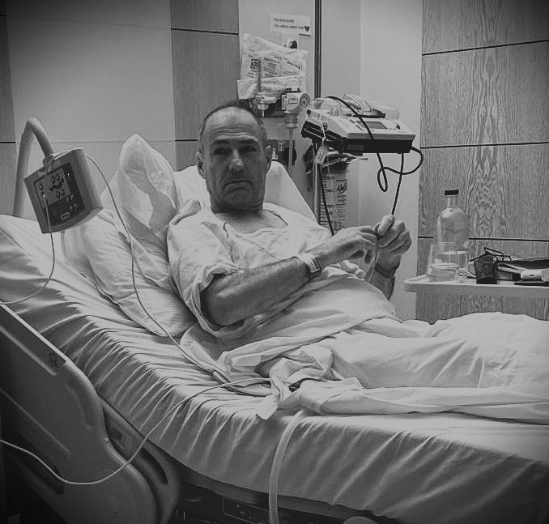
Laying in a hospital bed, without my depression medications on strong pain killers I had the most psychedelic dream I’ve can remember. Vivid colours and at the end my dad, who died 5 years back of dementia was sitting in the room with me. I went to hug him, but he disappeared as I came out of the dream. I cried, but it was so amazing to see the predementia Dad I knew, sitting up straight and relaxed.
I am in central London where he worked for decades, so maybe he did pop over to see me, I am open minded, not loose minded, on these matters of consciousness. Many dismiss what they cannot explain or describe to make sense out of their life. I like the mystery and the unknown, I am comforted by it. This is not gooey mush and I am not moving away from my engineering/scientific base, but embracing other ideas as may be having some merit given the weight of peer reviewed evidence.
Understanding us
I say “telling” the doctors about my medication, as I am a sensible, now reasonably read person who understands my conditions better than anybody. Yes, that is true, because much of what goes through your head is “just that” and “yes a bit more of that.” It is difficult to explain this to others and we are uncomfortable if we cannot narrate a story ^{[10]}. But that is ok with me, I cannot put into clear words some fleeting or longer-term emotions. I do not need a narrative any more.

Pushed into a box
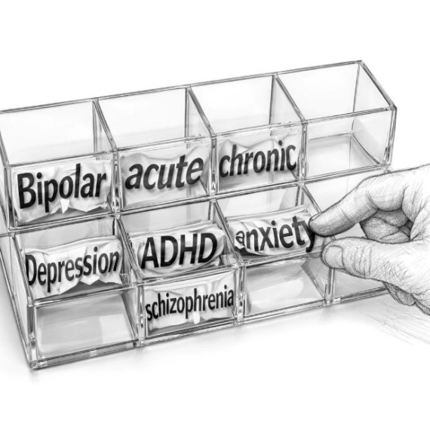
Coming to the end of this article of personal experience I am not saying stop your medication nor not to listen to professionals. I am saying that many mental health symptoms are categorised in clean boxes which is convenient but we are not beings that can be slotted into a category, depressed, anxious, bipolar, ADHD or other, we are complex beings. Our experiences have driven defence mechanisms to defend us from reliving the experience(s) but in doing that create a narrative for our lives that is false and holds us trapped, until we can understand that the voice of that “expert” is not real nor helpful.
You are not a bad person
“Good people end up in Hell because they can't forgive themselves.” Robin Williams
We must cope better than escape but in escaping you are not a bad person; you are trying to run from the traumatic experience(s) and can find positivity in a mechanism to be alive and escape the voice and suffering for a short period of time.
Self-prescribe your coping
If the medical profession will not prescribe walks, singing, sea, country, saying hello to dogs, cats, or laying down looking at the sky, dancing with friends through a sick or even a coping note, then we must self-prescribe these, preferably with someone else to keep you going. I am a runner and run alone. I occasionally join or am joined by someone at my pace and always so much more enjoy these runs. So many articles and posts I see talk about taking time for you, and this is critical in life under all circumstances. But just taking time is not good enough. Time must be well spent doing activities that stimulate your inner happiness and/or peace. I used to make believe I was doing myself good running until I nearly dropped, but swimming in the sea until I was (sensibly) tired was so much more enjoyable and enabled an inner experience, there I go with inadequate narrative again.

A hope for the future
Maybe the medical profession is missing a trick not providing country walks, trips to the sea, a karaoke night, meditation instruction and more. Maybe they could provide better and more detailed references, or trauma trees for homework where practicable. Could these be the savings that could be made for the health services, getting at the cause and preventing a decline to where medication is needed. Are we going the same way with antidepressants we used to be with antibiotics.
Could these be the primary mode of helping medical folk themselves who bear an incredible burden of society. As has been found in the fields of physical health and safety, the overbearing focus must be on causes of mental conditions, and enabling discover and healing through driving these early interventionist strategies of coping and discovery and moving away from treatment of the outcomes. However, if those that determine “treatment” and classification continue to have their own financial interests at heart through connection to the pharmaceutical industry, it will become even more important to self-prescribe these mechanisms. If those in the mental health arena continue to follow strict set diagnoses and prescribed “treatments” without pushing the boundaries and experimenting where safe to do so, we will perpetuate the current model and stay within the set paradigm we sit in today.
Society needs a shakeup, to stop relying on the overburdened health services to pick up the pieces caused by a failure in the way many societies now exist. Smart phones have reduced the need to meet face to face, maps on your phone mean you do not ask the way, older people are often in homes where they are not sharing their wisdom, family structures have fragmented, community dances are a more an event of the past and large companies (quietly) demand long hours on top of commutes, and so many other examples where connection has been lost to what many see as inevitable change, but should it be inevitable?
The office of National Statistics in the UK, in their data from 2018 – 2022 estimate 18 million work days are lost to mental health conditions a year. Albeit that this may have been impacted by COVID it is a staggering number of days lost. The London School of Economics estimates that the economic loss is equivalent to 5% of UK GDP.
Concluding
To end. I am convinced that inside us is the greatest healer, the knowledge, the capability to recover and heal towards being a happy, productive, and inspirational part of society and the bigger world around us. Knowledge, of your own unique condition is essential if you are to play a role in your own healing, and this more detailed knowledge should be made available in digestible forms, or when appropriate recommended books. Intense curiosity and self-prescription of coping mechanisms that aim to assist in discovery and healing is needed in addition to professional services, the government funded options which are stretched to breaking at least in the UK.
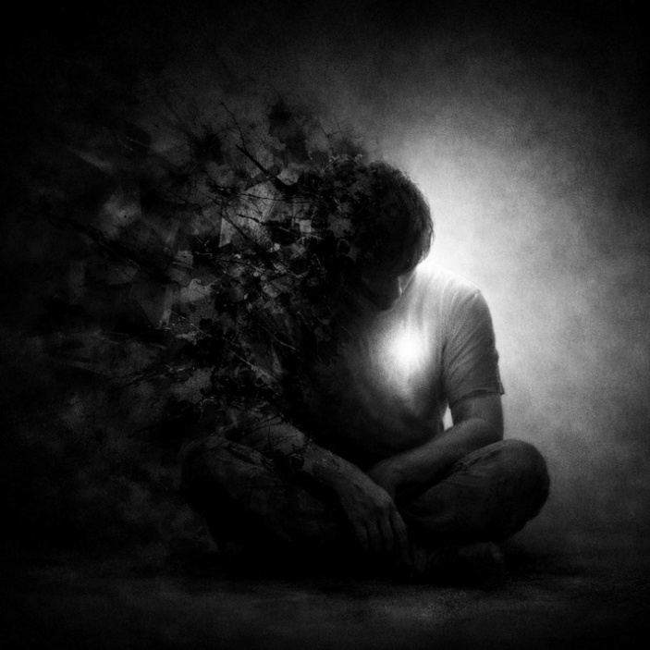
Companies and the medical profession can do much to assist their own employees well beyond current efforts by a keen focus on healing tools and coping whilst healing. Mental Health First Aid training, which looks at outcomes is a simple tool that must be seen as a starting point for companies to build upon and not the answer. Society and companies need to see the health services as a source of invaluable assistance but not the sole answer to the mental health crisis. Take the expected and potential losses and spend those funds on novel prevention and coping and reap the future benefits in productivity and longevity of employment. in so many countries. In promoting healing the medical profession and we need to develop flexible models that can stretch outside the current guidelines that perpetuate a focus on treating symptoms rather than cause.
Through “being in the moment” I know, and it cannot be disputed that we are all part of a very large being or world, interconnected with each other, the earth, the air and rivers and seas. Life flows from beginning to end and I believe onwards as we become part of this amazing entity.
We need a revolution not evolution from every corner of society if we are to walk out of the current mental health crisis many parts of the world find themselves in. We don’t have the time nor money for evolution.
My last note
You are never alone, however lonely and or desperate you feel. You are loved by so many you do not know and may not ever know, you are a part of us, a shared experience and we love you for being you.

References
Note: strict adherence to Harvard referencing is not in place
- John M. Slater – Music, Sharks and Mountains, Second Edition – 2024
- John M. Slater – Sing Through It – 2021
- Judith Joseph - High Functioning: Overcome Your Hidden Depression and Reclaim Your Joy – April 8, 2025
- National Institute for Health and Care Excellence NICE.org.uk Definition of Depression 2025
- US National Library of Medicine A comparison of DSM IV and DSM-5 Panel memberfs’ Financial Association with Industry by Lisa Cosgrove and Sheldon Krimsky
- NHS Constitution
- Norman Doidge M.D. - The Brain That Changes Itself: Stories of Personal Triumph from the Frontiers of Brain Science - December 18, 2007
- Office of National Statistics loss due to illness figures 2018 - 2022
- Psychology today - Humans are as motivated by status as pack animals. Posted December 9, 2009
- Rose Cartwright – Maps we carry – January 2025
- USA DSM-5-TR 2013
- World Health Organisation (WHO) ICD-11

